17. Plot of a R%-G% Diagram
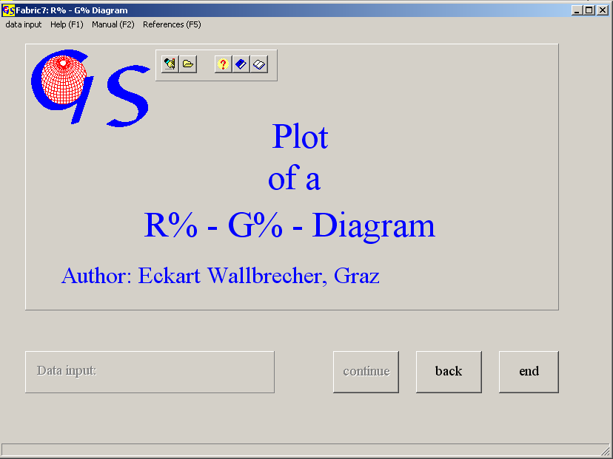
Fig. 1

This program (Fig. 1) plots the degree of preferred orientation (R%) against the cylindricity (G%) of a spherical distribution. Definitions are explained in pfrogram 8. The degree of preferred orientation is defined as:

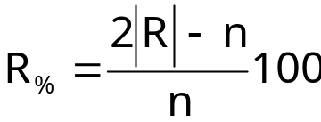
The cylindricity is
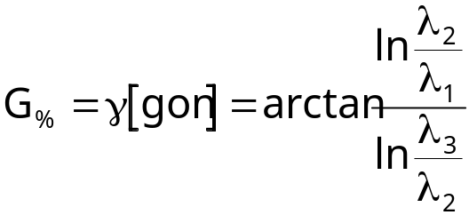

Fig. 2 shows the form for manual input. Degree of preferred orientation and cylindricity are written in the fields. Each pair of data is represented by a symbol which must be chosen from the field “Symbol”.

Input from a file is similar as in all other programs. The extension of a data file is ‘.RGD‘.

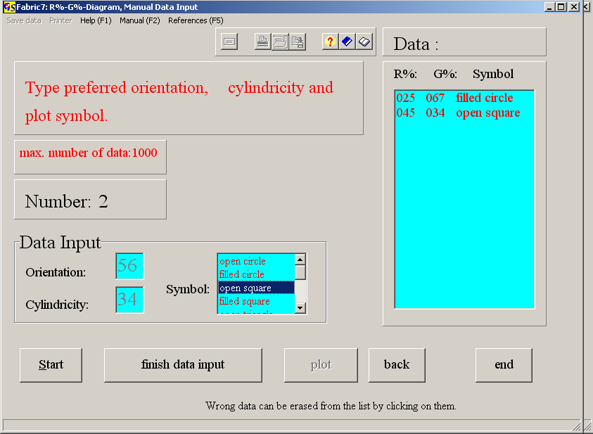
Fig. 2

Fig. 3 shows the graphic form.

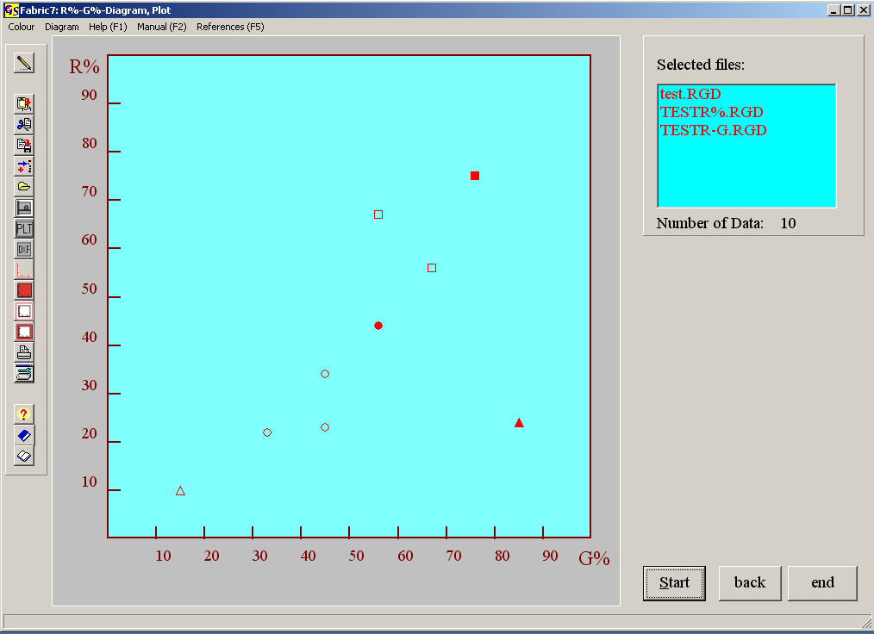
Fig. 3

